1. 原来接的是I2C2 M0，现改为接I2C2 M1
Connect I2C2 M1 instead of I2C2 M0
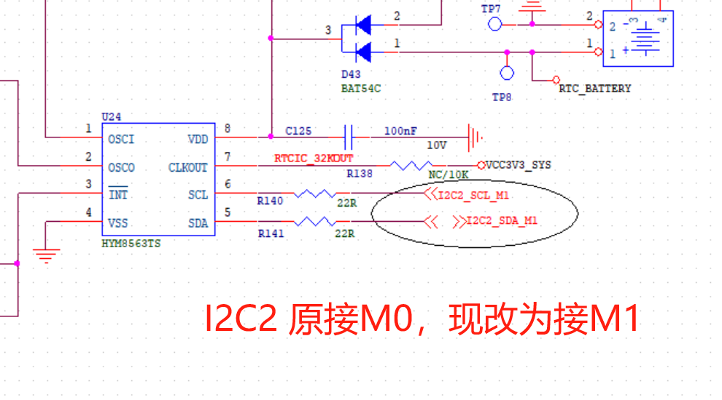

- 版本号原V1.35, 现改为V1.36
Change HW Version Number from V1.35 to V1.36
- 拼板改成邮票孔，分板
Change panel to stamp holes for depanelization

